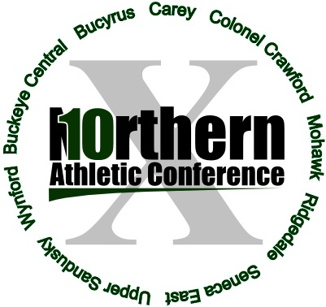

All-Northern 10 Athletic Conference Volleyball 2016

First team School Yr Po
Addie Thiery Mohawk 12 OH
Jenna Seigel Colonel Crawford 11 MH
Sydney Kin Carey 11 MH
Jenna Karl Buckeye Central 11 OH
Chelsey Trusty Mohawk 12 S
Addie Ackerman Buckeye Central 11 S
Emily Pursell Mohawk 12 L
Bailey Agin Buckeye Central 11 DS

Second team School Yr Po
Tara Zinser Wynford 12 MH
Sarah Heydinger Buckeye Central 12 MH
Taylor Gimenez Seneca East 12 MH
Destini Oler Mohawk 11 OH
Jenna Smalley Carey 12 S
Danielle Horsley Colonel Crawford 10 S
Erika Rosario Upper Sandusky 12 L
Bailey Alspach Wynford 11 L
Hannah Zimmerman Carey 11 DS

Honorable mention School Yr Time
Erin Baldosser Buckeye Central 12 DS
Shaina Orewiler Bucyrus 11 OH
Dana Worst Carey 11 L
Samantha Mutchler Colonel Crawford 12 MH
Emily Conner Mohawk 12 MH
Megan Mulvaine Ridgedale 12 OH
Aubrey Saylors Seneca East 11 MH
Rachel Martin Upper Sandusky 12 OH
Jenna Coffman Wynford 11 S

Player of the year
Jenna Karl, Buckeye Central

Coach of the year
Jackie Reinhart, Buckeye Central

