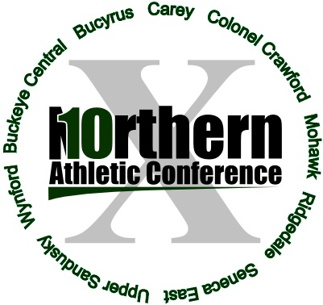

All-Northern 10 Athletic Conference Golf 2015

First team School Yr Avg
Chet Margraf Mohawk 11 40.10
Tanner Zaebst Buckeye Central 12 40.20
Brayden Dunlap Mohawk 12 40.20
Johnny Diehm Seneca East 11 40.30
Marcus Miller Carey 10 40.60
Tommy Martin Upper Sandusky 12 41.70
Mitchill Reasoner Ridgedale 10 42.20

Second team School Yr Avg
Carson Weinandy Mohawk 11 42.30
Zane Kitzler Upper Sandusky 12 42.60
Alex Kimmet Carey 11 43.00
Trey Bame Carey 10 43.50
Nick Gremling Colonel Crawford 11 44.00
Monroe Britton Ridgedale 12 44.10
Alex Forehand Seneca East 10 44.10

Honorable mention School Yr Avg
Keegan Sims Bucyrus 12 44.50
Riley Kalb Seneca East 12 44.80
Turner Dilley Upper Sandusky 11 44.80
Dillon Weithman Buckeye Central 12 45.10
Billy Dunlap Mohawk 11 45.20
Chase Wagner Carey 11 45.86
Nathan Kimmet Mohawk 11 46.30

Player of the year
Chet Margraf, Mohawk

Coach of the year
Dave Myers, Mohawk

